**EXPERIMENT – 4**

**AIM: -** Setup and configure a LAN (Local area network) using a Switch and Ethernet cables in your lab.

**How to set up a LAN:**

* **Plan and Design Network Topology:** Decide on network layout and equipment location.
* **Gather Equipment:** Use 4 computers, an 8/16/24-port switch, and 4 Ethernet cables.
* **Connect Devices to Switch:** Plug Ethernet cables from each computer into the switch.
* **Assign IP Addresses:**

Log in as Administrator on each PC.

Go to **Network and Internet Connections > Local Area Connection/Ethernet**.

Select **Properties > TCP/IPv4 > Use the following IP address**, then assign:

* + PC1: 10.1.1.1, Subnet Mask: 255.0.0.0
  + PC2: 10.1.1.2, Subnet Mask: 255.0.0.0
  + PC3: 10.1.1.3, Subnet Mask: 255.0.0.0
  + PC4: 10.1.1.4, Subnet Mask: 255.0.0.0
* **Configure the Switch:** Connect a computer to the switch and log in to its web interface. Set the switch's IP address to 10.1.1.5, Subnet Mask: 255.0.0.0.
* **Verify Connectivity:** Use the **ping** command to test connection between devices.
* **Share Folder:** Select a folder, go to **Properties > Sharing tab**, and share it with everyone on the LAN.
* **Access Shared Folder:** Try accessing the shared folder from other network computers.

**OUTPUT: -**

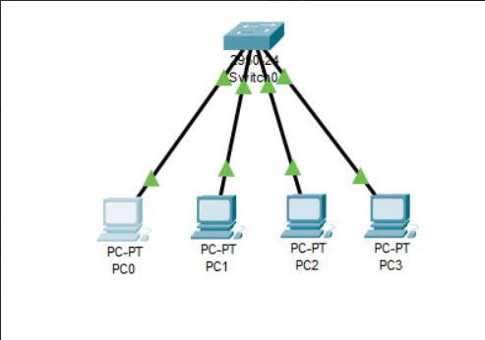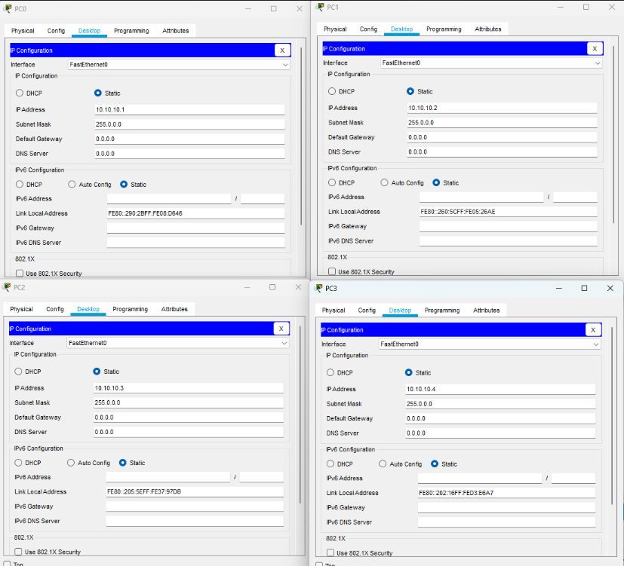

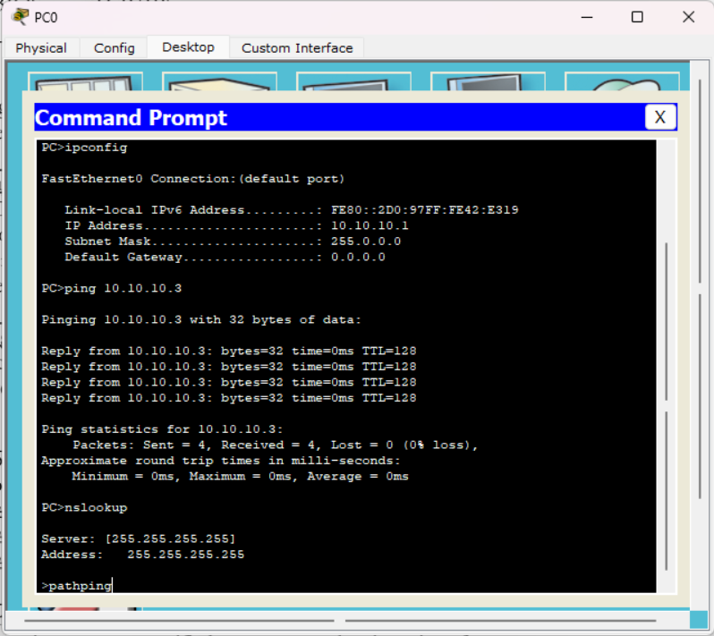

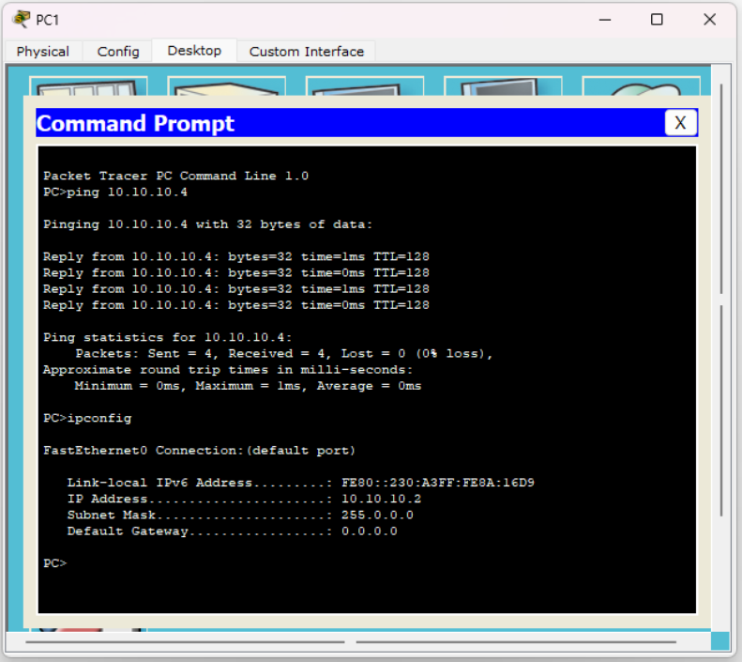

**RESULT: -**

LAN Configuration using Switch has been done and studied successfully.